Full Sized Rail Manufacturing
The full-size rail design will differ from our prototype in material, size, and manufacturing method. The increased budget for the full-sized device allows us to design a custom design a rail system for our use rather than selecting an existing product. The best way to accomplish custom rails is through the use of CNC machining. CNC machining allows for greater precision compared to traditional machining by having tighter tolerances and reducing human error through automation. The other main advantage of using CNC is consistency and repeatability; this allows for manufacturing of scaled rails for different sized UAVs and boats while maintaining consistency between various sizes.
CNC, in addition to working seamlessly with CAD software allowing the designs to be pushed directly into production, increases manufacturing safety. CNC is executed in enclosed machining environments with automated tool changes and positioning. This allows the operators to minimize exposure to moving parts and in turn minimize the likelihood of an injury.

Materials:
The full-sized rail needs to be approximately 2 meters in length according to our force calculations. Using this length for pricing and weight of the individual rails allows us to make decisions on what material is best suited for our project. The two most obvious material choices for our rail design are aluminum and stainless steel.
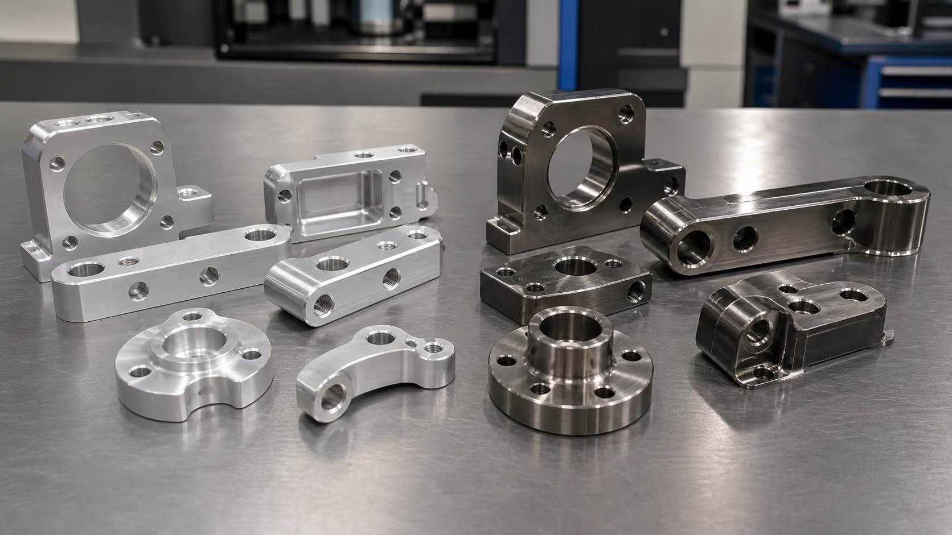
Figure 1: Aluminum and Stainless Steel CNC parts

Aluminum
Table 1: Aluminum Property Table
Property | Value
Density | 2.70–2.81 g/cm³
Yield Strength | 276 / 503 MPa
UTS | 310 / 572 MPa
Elastic Modulus | 68.9–71.7 GPa
Specific Strength (UTS/ρ) | ~200 kN·m/kg
Corrosion Resistance | Good with anodize or chromate
Raw Material Cost | $3–5/lb ($7–11/kg) bar stock
Machinability Rating | Excellent — 2–4× faster than stainless

The main advantage of using aluminum in our system is the strength to weight ratio. The specific strength of aluminum is a little over three times that of stainless steel. Weighing 65% less than stainless steel the lighter aluminum puts less strain on the angle adjustment actuators. The greatest concern with aluminum is the much lower elastic modulus, this increases the risk of rail deflection which reduce launching consistency.

Stainless Steel
Table 2: Stainless Steel Property Table
Property | Value
Density | 7.65–8.00 g/cm³
Yield Strength | 205–1,170 MPa
UTS | 515–1,310 MPa
Elastic Modulus | 193–200 GPa
Specific Strength (UTS/ρ) | ~65 kN·m/kg
Corrosion Resistance | Excellent — inherent Cr₂O₃ passive film
Raw Material Cost | $4–8/lb ($9–18/kg) bar stock
Machinability Rating | Moderate to challenging

Stainless steel shines in both strength and corrosion resistance. The increased elastic modulus leads to more consistent launches, and the corrosion resistance allows the launcher to have a longer lifespan. The increased density of stainless steel not only impacts the weight of the design but how difficult it is to manufacture. Stainless steel takes 3-5 times longer to CNC compared to that of aluminum.

Cost
The costs of CNC are mainly based on machining time, whereas only 20-30% comes from the raw material cost. With the increased manufacturing time as well as the higher material cost stainless steel can cost 1.5-2.5 times more than aluminum.

Final Decision
The best material choice for our full-sized rail design is stainless steel. For our systems design the strength and rigidity are important in maintaining consistent launches. The elastic modulus in stainless steel is slightly less the three times than that of aluminum, in an environment where potential deflection from the waves is a concern, a higher elastic modulus minimizes that risk. The increased corrosion resistance of stainless steel also allows the launcher to have a greater resistance to sea spray. Over time an aluminum rail will corrode faster than stainless, this allows the launcher to remain operational longer in the harsh marine environment. These benefits outweigh the cons of increased price and weight; with the harsh marine environment a priority is placed on strength and durability.

References
[1] “The benefits of CNC machining over traditional machining methods,” Cast Technologies, https://casttechnologies.net/the-benefits-of-cnc-machining-over-traditional-machining-methods/ (accessed Nov. 12, 2026).
[2] “MakerStage,” Aluminum vs Stainless Steel for CNC Parts (2026), https://www.makerstage.com/resources/aluminum-vs-stainless-steel (accessed Nov. 12, 2026).
[3] “Stainless steel vs. aluminum,” Unified Alloys, https://www.unifiedalloys.com/blog/stainless-steel-vs-aluminum/ (accessed Nov. 12, 2026).

